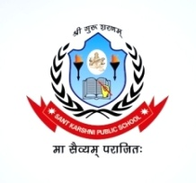
SANT KARSHNI PUBLIC SCHOOL
Jalesar Road Sadabad
Affiliated to CBSE (No.-2131984)
Ph. 7830730300, 7500401700
Email.id:- kpssadabad@gmail.com
Website: www.santkarshnipublicschool.in

HOLIDAY HOMEWORK 2023-24
CLASS- II
ENGLISH :
WORKSHEET TASK- 1, 2 to 15, Write the noun and its kind on chart paper with picture and colour.
MATHS
WORKSHEET TASK- 1 to 19 (Write 1 to 10 Ordinal number name on chart paper with colour)
EVS
WORKSHEET TASK- 1 to 20
COMPUTER
WORKSHEET TASK- 1 to 6 (Draw a computer diagram with it part(keyboard and CPU) with colour)
ART
Draw, Flag, Lotus and peacock on chart paper with colour.
HINDI
WORKSHEET TASK- 1 ls 14 ¼Loj] O;atu dk pkVZ cuk;s jxksa ds lkFkA½
Hindi Writing Book ¼igy lqj& ysf[kdk½ page no. 2 to 10, fganh lqys[k 5 ls 32
English writing book (Wright Bright) page no. 3 to 20, Creative Cursive Writing

Complete your holiday homework in holiday homework book (Book name – Smart activities for holidays)

Note:- Summer holiday homework is available on school website:- www.santkarshnipublicschool.in and respective classes whatsapp groups.

