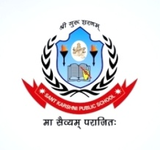
SANT KARSHNI PUBLIC SCHOOL
Jalesar Road Sadabad
Affiliated to CBSE (No.-2131984)
Ph. 7830730300, 7500401700
Email.id:- kpssadabad@gmail.com
Website: www.santkarshnipublicschool.in

HOLIDAY HOMEWORK 2023-24
CLASS- LKG

ENGLISH
Write the Capital & Small Letters Aa to Zz write the spellings A to M, (Two times)
MATHS
Write table of 2 and 3. Write Number name 1 to 10 (Two times)
(Mathematics Book:-) Do page no 15 to 34
(Smart Activities Book :-) Do worksheet 1 to 13 on page no 91 to 103
GK
Paste any five picture of water animals and write their name. (two times)
Paste any five picture of flower and write their name. (two times)
Paste any five picture of insects and write their name (Two times)
HINDI
v ls K rd fyf[k,A nks v{kj okys 10 “kCn fy[k,A (Two times)
( “kCn Hindi Book ) Do page no. 22 to 32
School Activities Book Do Page No. 61 to 66 (Worksheet - 9 to 14)
Activity Hand painting & Finger Painting A4 size sheet (Any One)
Note – Do all work 3 in one notebook.
Complete your holiday homework (Happy Vacation)

Note:- Summer holiday homework is available on school website:- www.santkarshnipublicschool.in and respective classes whatsapp groups.

